Install Portable Python(2.7.3.1)

- Download and run PortablePython_2.7.3.1.exe;
- Install Portable Python into “PortableTrac's Home”;
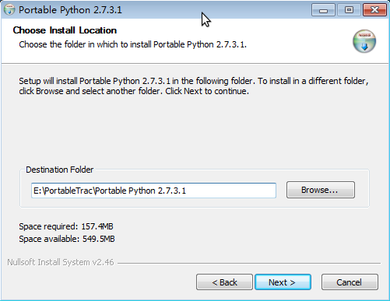
- Modules: Unselect “Django”, select “wxPython”;
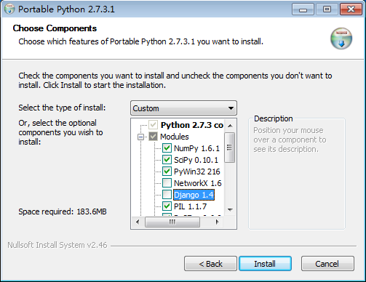
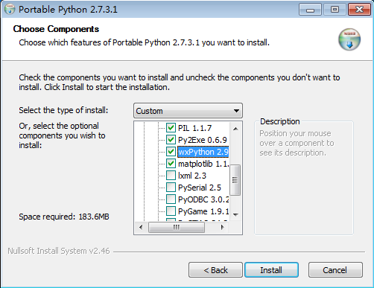
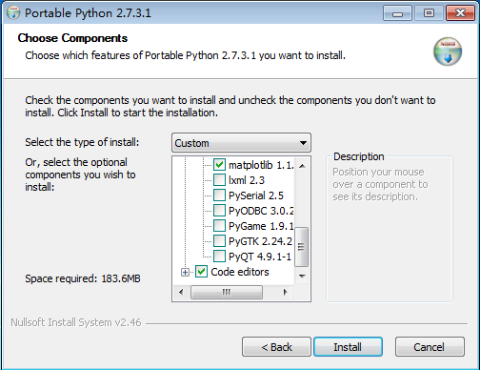
- Note:
to avoid the “C Run-Time Error R6034”, if you plan to run with apache httpd, please don't install “PIL”:
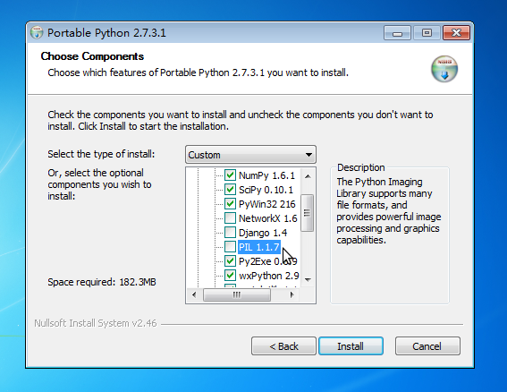
for detail, see msdn “ms235560(v=vs.90).aspx”;
- END

